Assignment 24 - Deploying a Java Spring Boot Application in Azure Kubernetes Service(AKS)

Step1

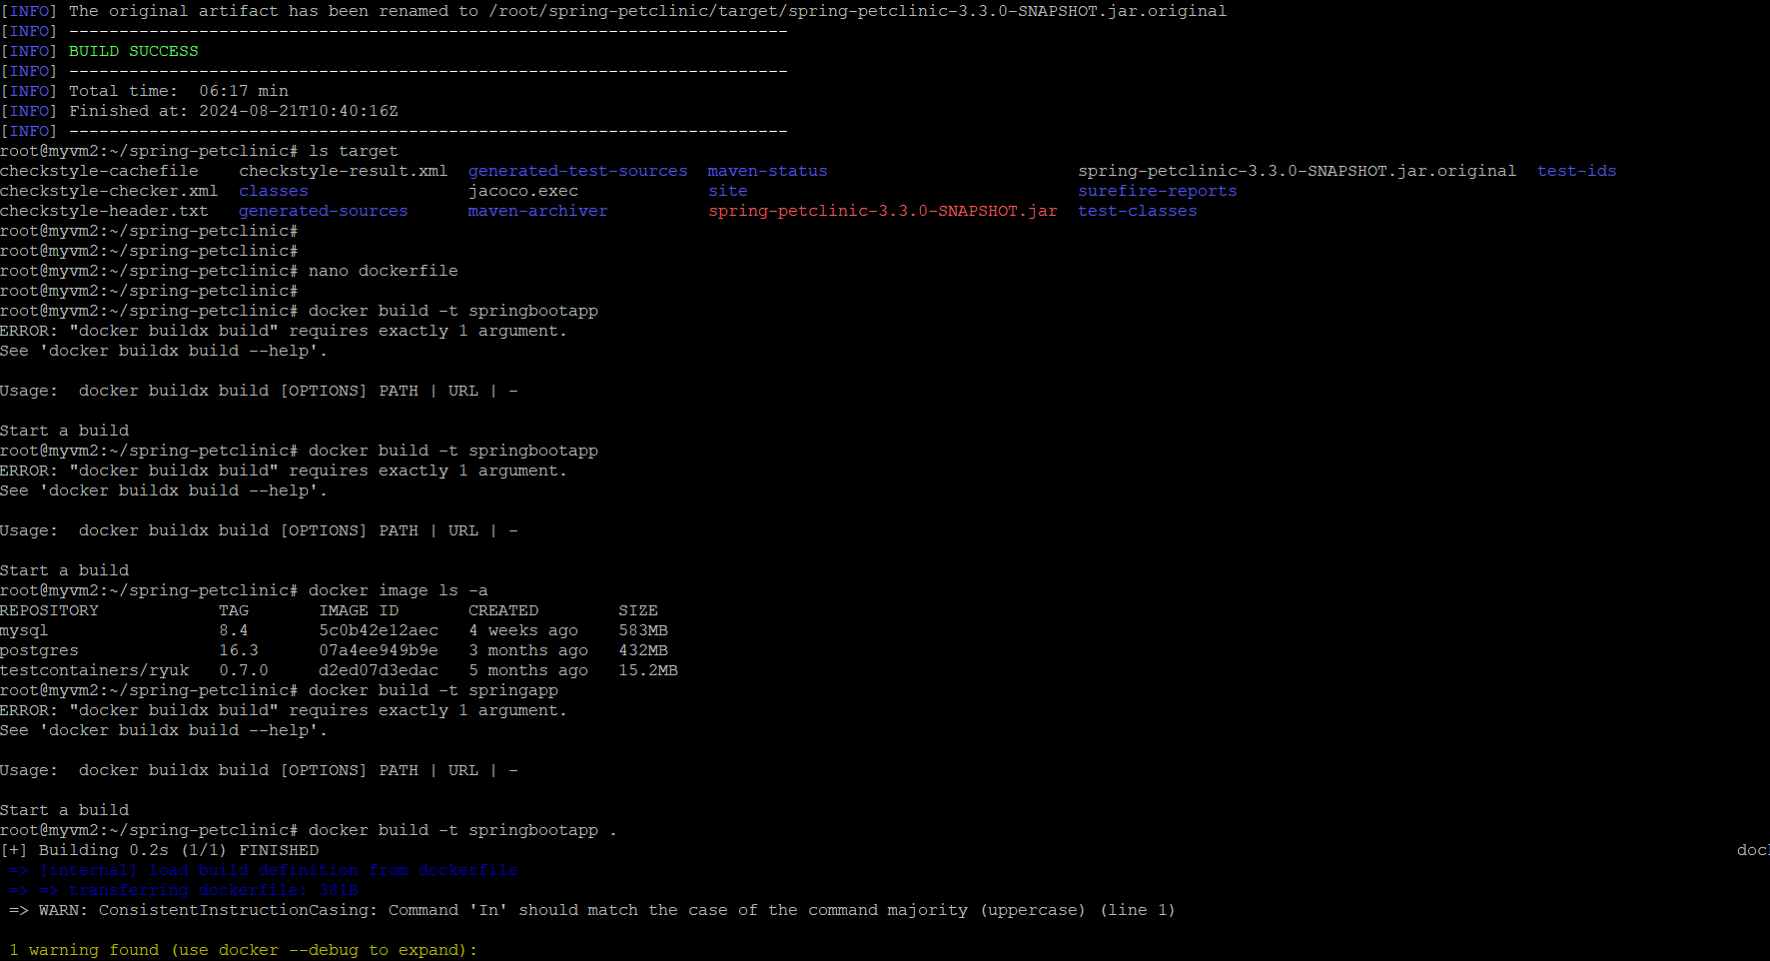

Step2

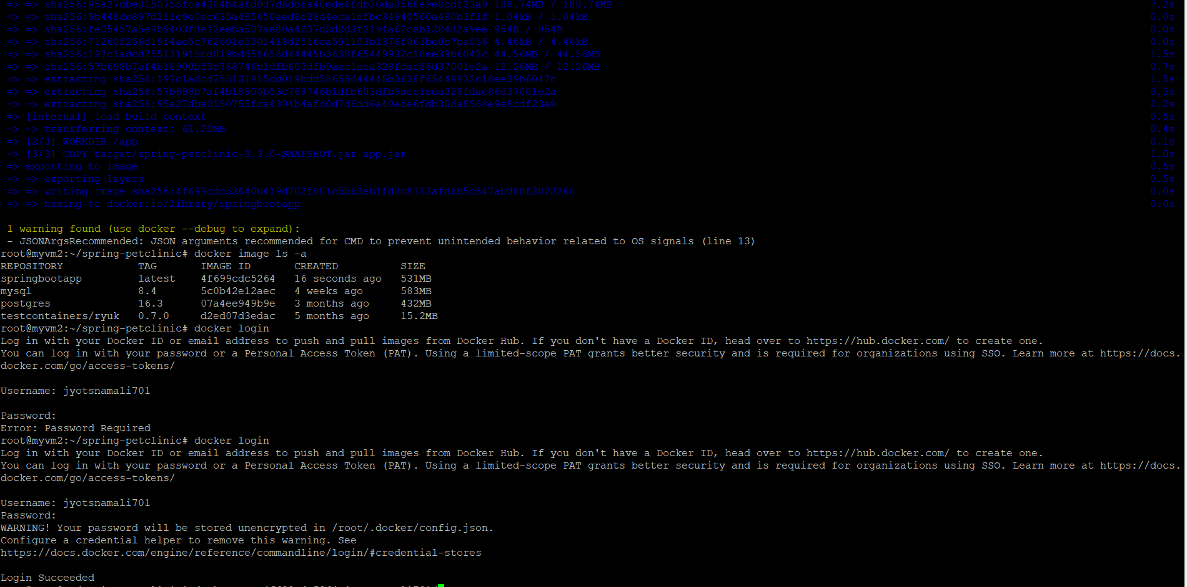

Step3

